Name: ____________________________________ | 
Year 12 Essentials

Mathematical thinking process questions

You will need to apply the mathematical thinking process:

• interpret the task and gather the key information
• identify the mathematics which could help to complete the task
• analyse information and data from a variety of sources
• apply their existing mathematical knowledge and strategies to obtain a solution
• verify the reasonableness of the solution
• communicate findings in a systematic and concise manner.

Weeks 1 &2
Scenario:

James has just bought a new house and needs to decorate his bedroom.
3.5 m

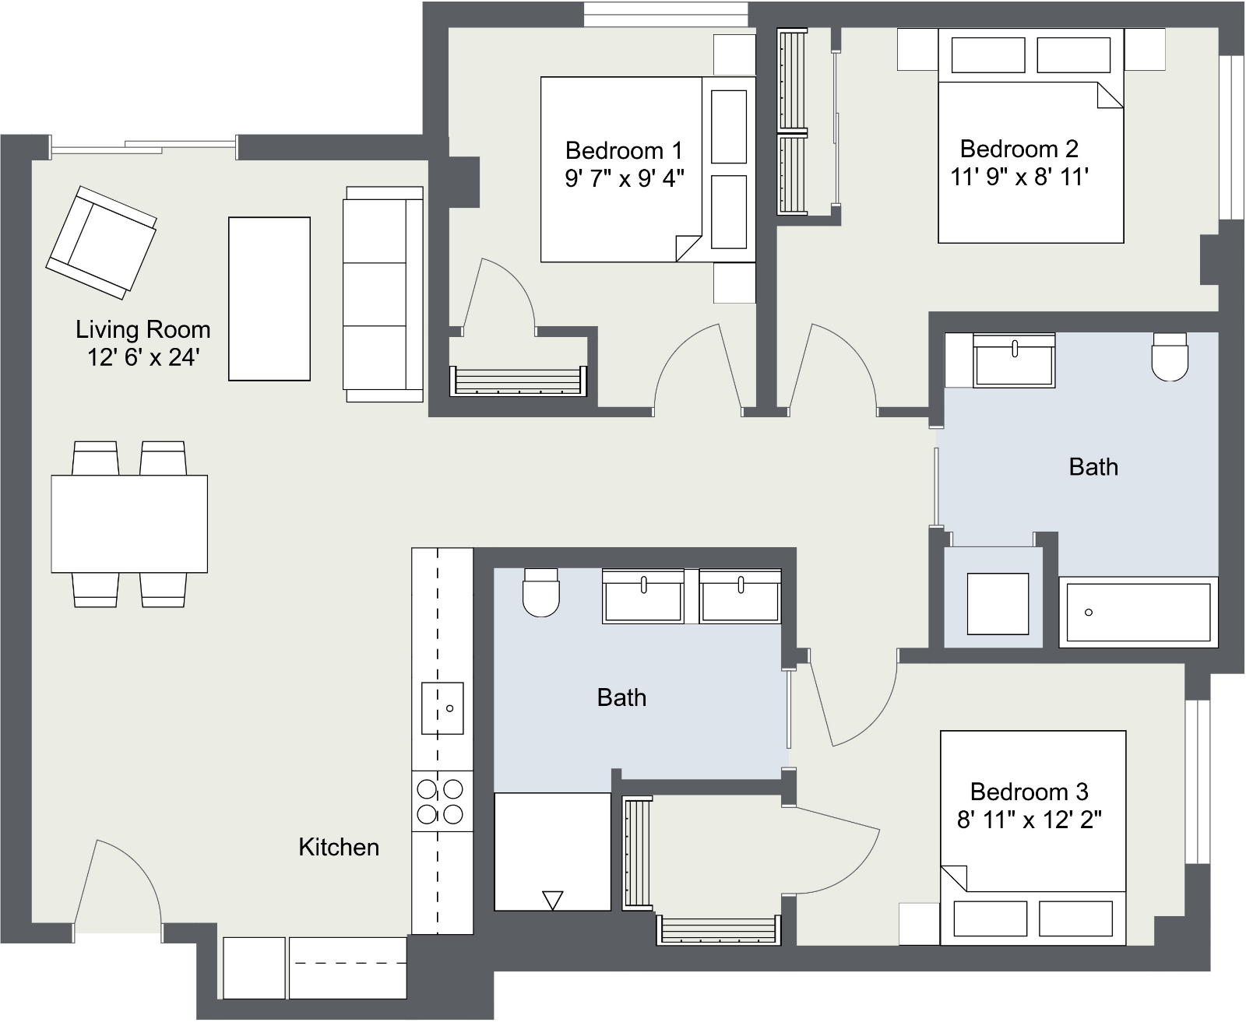

3m
4 m

Task 1
He wants to put skirting board around the room. How much does he need to buy?

Task 2
He also needs to paint the room, including the ceiling and replace the carpet. How much does he does he need to buy?

Week 3 - Task 3
Scenario:
Collect cardboard boxes from home and tape them together to make a box which has a volume of one cubic meter (height, length and width each 1 meter).
Use your box to answer these questions:
- Estimate the number of these boxes which are needed to fill your classroom. Explain your answer.
- Use this figure to estimate the number of litres of water that would fill your classroom.

